**C Language Syllabus**

# Introduction and First Program 45 mins

Why Programming 21 mins

History of C Language 10 mins

Hello World Program 14 mins

# Variables and Data types 50 mins

Identifiers in C 10 mins

Variables and DataTypes 20 mins

Constants 20 mins

# Console IO Operations 48 mins

Printf and Scanf 39 mins

Unformatted IO Functions 09 mins

# Operators and Expressions 70 mins

Expressions and Arithmetic Operators 23 mins

Relational and Logical Operators 16 mins

Bitwise Operators 31 mins

# Control Flow Statements 209 mins

If Statement 48 mins

Switch Statement 21 mins

Unconditional Branching using goto statement 11 mins

While Loop 63 mins

Do While Loop 07 mins

For Loop 33 mins

Break and Continue 13 mins

Special Cases 13 mins

# Working with Functions 83 mins

Introduction and Writing Functions 34 mins

Scope of Variables,Storage Classes,Pass by Value and reference

35 mins

Recursion 14 mins

# Working with Arrays 89 mins

Arrays Declaration and Initialization 20 mins

Sample Programs using Arrays 23 mins

Arrays as Function Parameters 18 mins

2-Dimensional Array 28 mins

# Pointers 142 mins

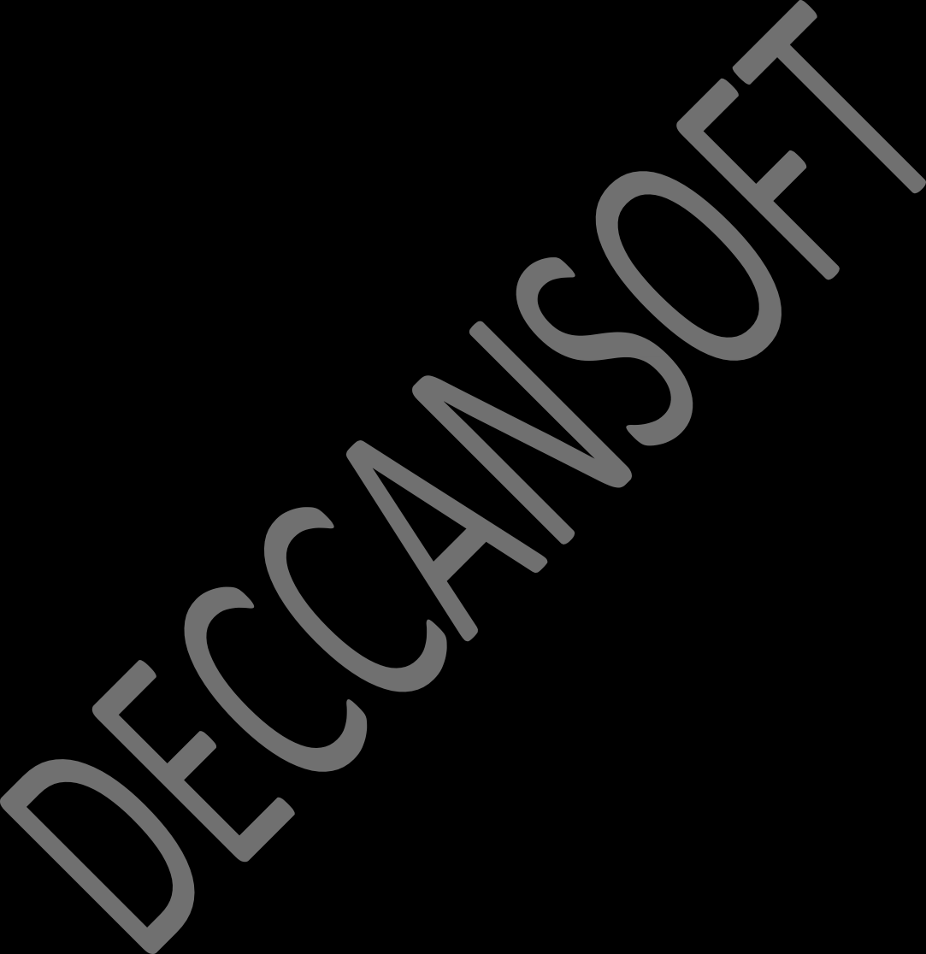Introduction to Pointers 23 mins

Pointers as Function Parameter 17 mins

Pointer Arithmetic 06 mins

Pointers and Arrays 30 mins

Function Pointers 32 mins

Dynamic Memory Allocation using malloc 25 mins

calloc and comparision with malloc 09 mins

# String Handling 76 mins

Introduction to Strings 13 mins

Sample Program 31 mins

More Sample Programs 09 mins

Standard String Library Functions 11 mins

Array of String 12 mins

# Structures and Unions 71 mins

Declaring and Instantiating Structures 18 mins

Structure as Parameter and Pointer to Structure 15 mins

Enumerated Data Type 08 mins

Union 21 mins

Bit Fields 09 mins

# File Handling 70 mins

What is a Stream 18 mins

File Handling-Writing and Reading Characters 17 mins

Writing and Reading Structure in Text Format 14 mins

Writing and Reading in Binary Format 21 mins

# Pre-Processor Directives 42 mins

Understanding Pre-Processor directives 23 mins

Header Files and Project 19 mins

# Command Line Arguments and Variable Arguments

**20 mins**

Command Line Argument 09 mins

Variable Number of Arguments 11 mins

# Searching and Sorting 157 mins

Linear Search 19 mins

Iterative Binary Search 19 mins

Recursive Binary Search 10 mins

Bubble Sort 21 mins

Selection Sort 16 mins

Insertion Sort 17 mins

Quick Sort 30 mins

Merge Sort 25 mins

# Stack 105 mins

Introduction to Data Structures 09 mins

Stack Using Arrays 26 mins

Stack Using Linked List 27 mins

Infix to Postfix Expressions 43 mins

# Queue 41 mins

Queue Using Arrays 24 mins

Queue Using Linked List 17 mins

# Linked List 144 mins

Introduction to Linked List 14 mins

Single Linked List 54 mins

Double Linked List 34 mins

Circular Linked List 42 mins

# Trees 116 mins

Introduction to Trees 27 mins

Programming Tree - 1 51 mins

Programming Tree - 2 38 mins

